**DAILY ONLINE ACTIVITIES SUMMARY**

|  |  |  |  |  |  |  |  |
| --- | --- | --- | --- | --- | --- | --- | --- |
| **Date:** | **30/06/2020** | | | | **Name:** | **Churashma** | |
| **Sem & Sec** | **4th SEM 'A' Section** | | | | **USN:** | **4AL18CS019** | |
| **Online Test Summary** | | | | | | | |
| **Subject** | | **No test** | | | | | |
| **Max. Marks** | | **-** | | **Score** | | **-** | |
| **Certification Course Summary** | | | | | | | |
| **Course** | **Blockchain basics** | | | | | | |
| **Certificate Provider** | | | **greatlearning academy** | **Duration** | | | **2.5 hours** |
| **Coding Challenges** | | | | | | | |
| **Problem statement 1: Write a C++ Program to Move all zeroes to end of array using Two-Pointers.**  **Problem statement 2: Write a C Program to generate first n Ugly Numbers.**  **Problem statement 3: Write a C Program to check whether the number is Ugly or not.** | | | | | | | |
| **Status: completed** | | | | | | | |
| **Uploaded the report in Github** | | | | **yes** | | | |
| **If yes Repository name** | | | | **https://github.com/Churashma/Lockdown-coding** | | | |
| **Uploaded the report in slack** | | | | **yes** | | | |

ONLINE TEST DETAILS: No test

CERTIFICATION COURSE DETAILS: Today I studied about what is Blockchain.Blockchain is the latest technology trend to follow in the wake of IoT and AI and promises a new model for traceability, supply chain transparency, compliance monitoring and auditability.Blockchain elevates manufacturing traceability and transparency to a totally new level while improving process efficiencies and reducing costs.

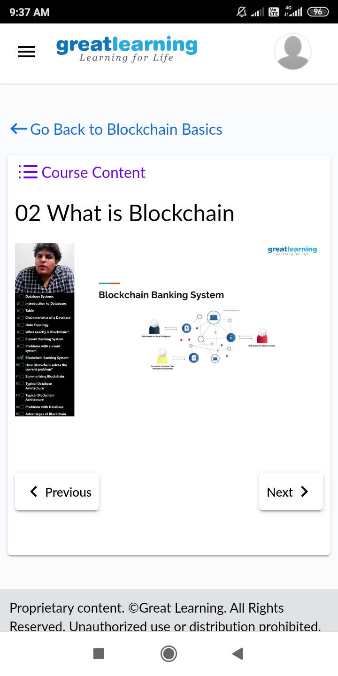

**CODING CHALLENGES DETAILS**:

Problem statement 1: Write a C++ Program to Move all zeroes to end of array using Two-Pointers.

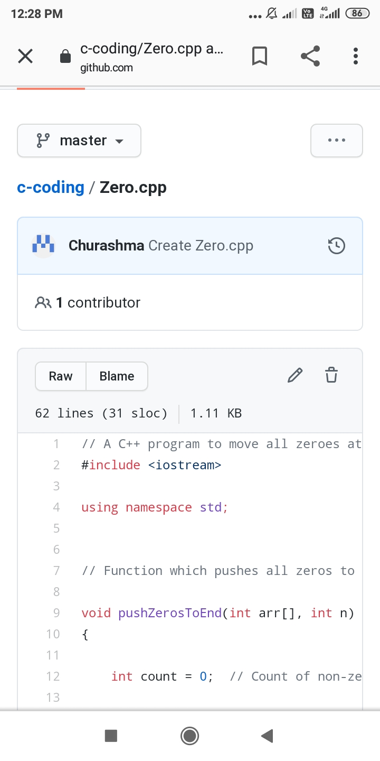

Problem statement 2:Write a C Program to generate first n Ugly Numbers.

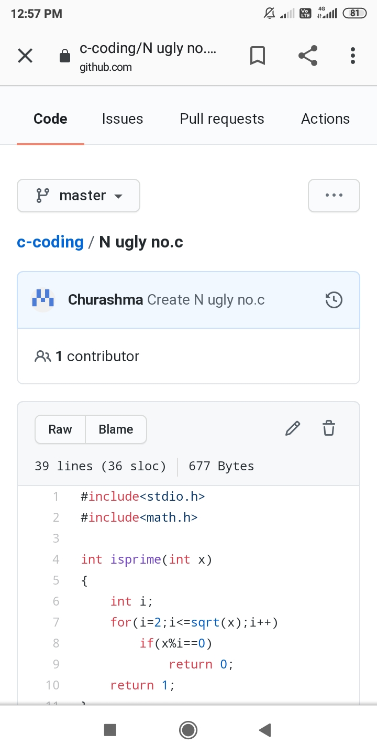

Problem statement 3: Write a C Program to check whether the number is Ugly or not.

